//currency

package packex;

public class CurrencyDEY{

  public double dolToRup(double dol){

    return dol\*68;

  }

  public double ruptoDol(double rupee){

    return rupee/68;

    }

  public double eurotoRup(double euro){

    return euro\*81;

    }

  public double ruptoEuro(double rupee){

    return rupee/81;

    }

  public double yentoRup(double yen){

    return yen\*0.59;

    }

  public double ruptoYen(double rupee){

    return rupee/0.59;

    }

 }

//distance

package packdis;

public class Distance{

  public int metertoKm(int meter){

    return meter\*100;

    }

  public double kmtoMeter(double km){

    return km/1000;

    }

  public double miletoKm(double miles){

    return miles\*1.609;

    }

  public double kmtoMile(double km){

    return km/1.609;

    }

}

//time

package packtime;

public class Time{

  public int hourstoMts(int hours){

    return hours\*60;

    }

  public double mtstoHour(double mts){

    return mts/60;

    }

  public int hourtoSec(int hours){

    return hours\*3600;

    }

  public double sectoHour(double sec){

    return sec/3600;

    }

  public int mtstoSec(int mts){

    return mts\*60;

    }

  public double sectoMts(double sec){

    return sec/60;

    }

}

//main

import packex.\*;

import packdis.\*;

import packtime.\*;

public class Static{

  public static void main(String []args){

   CurrencyDEY c=new CurrencyDEY();

   Distance d=new Distance();

   Time t=new Time();

    System.out.println(c.eurotoRup(55.7));

    System.out.println(d.kmtoMile(55));

    System.out.println(t.hourtoSec(5));

   }

  }

OUTPUT

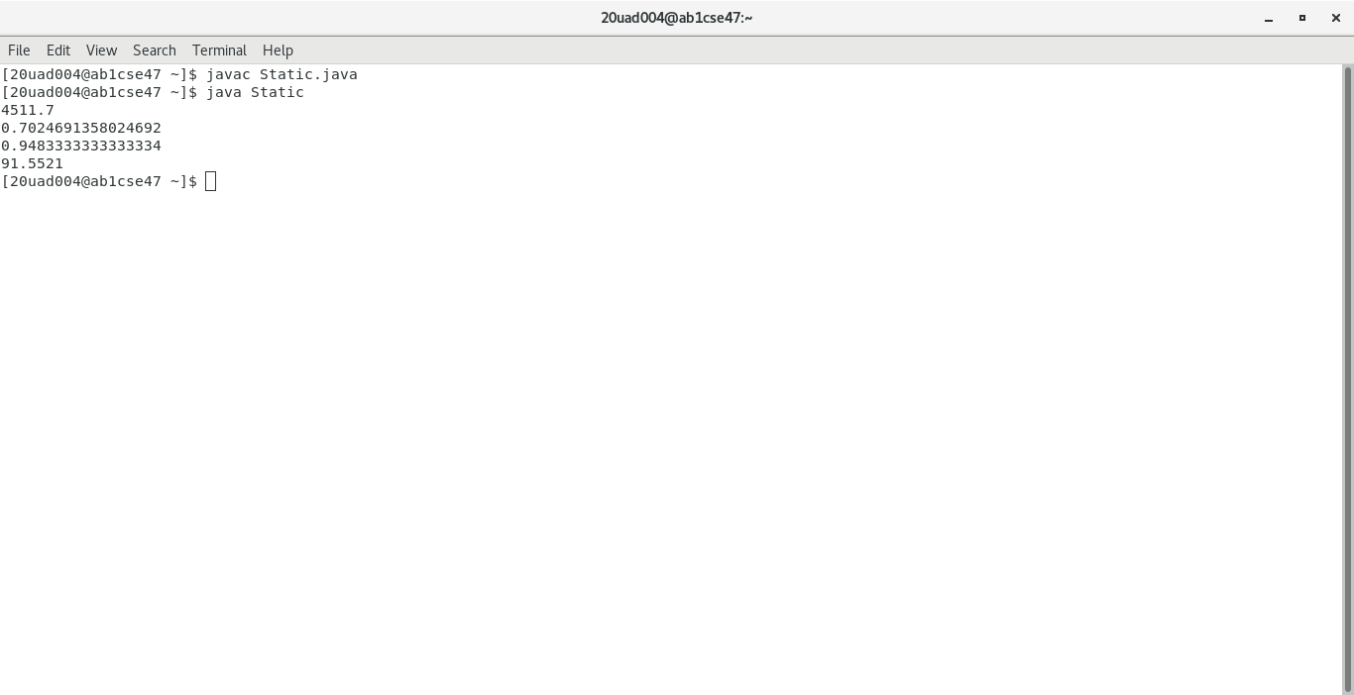

OUTPUT

